Preparing for a Successful Interview Guide

**“40% of interviewers state that overall confidence was a reason for not taking their candidacy further.”**

**–** [**Twin Employment & Training**](https://www.twinemployment.com/blog/8-surprising-statistics-about-interviews)​

**Key Takeaways:**

1. By the end of this Milestone, you will be able to demonstrate successful interviewing strategies.
2. Review this guide, and [mark complete on BCS.](https://www.bootcampspot.com/login)​
3. For more insight on interviewing, [click here to register for a behavioral or technical interviewing workshop](https://careerservicesonlineevents.splashthat.com/).

Employer Competitive candidates succeed in the interview process by preparing for common questions and practicing the stories that illustrate their skills, unique talent, and experiences. They understand how to confidently speak about their technical and transferable skills in a way that sells their professional value to employers.

For a practice session on interviewing, [click here to register for a behavioral or technical interviewing workshop](https://careerservicesonlineevents.splashthat.com/).

**GETTING STARTED**

1. Review the guide below for insight on behavioral and technical networking.
2. If you’d like additional support with interviewing, review our [‘Step-by-Step Guide to Preparing for a Successful Interview’](https://careerservices.gitbook.io/career-resources-data-analytics-library/-LjRMfertuZzhAIzJI8A/prepare-for-a-successful-interview/step-by-step-guide-to-preparing-for-a-successful-interview) or review the resources we’ve included at the end of this guide.
3. Once you’re done, [mark this milestone complete on the Career Services page in BCS](https://www.bootcampspot.com/login). Reminder: This Milestone does not require a submission to a Profile Coach.

**BEHAVIORAL INTERVIEWING**

Behavioral interviews consist of concise yet detailed descriptions of your past professional accomplishments and experiences with an emphasis on how you reacted to different situations. Employers listen to your “stories” to evaluate if you have the skills and experience that meet their job requirements and fit the company culture.

The secret to nailing your behavioral interview is to have thoughtful stories that are consistent with your brand and also illustrate your strengths and professional value.

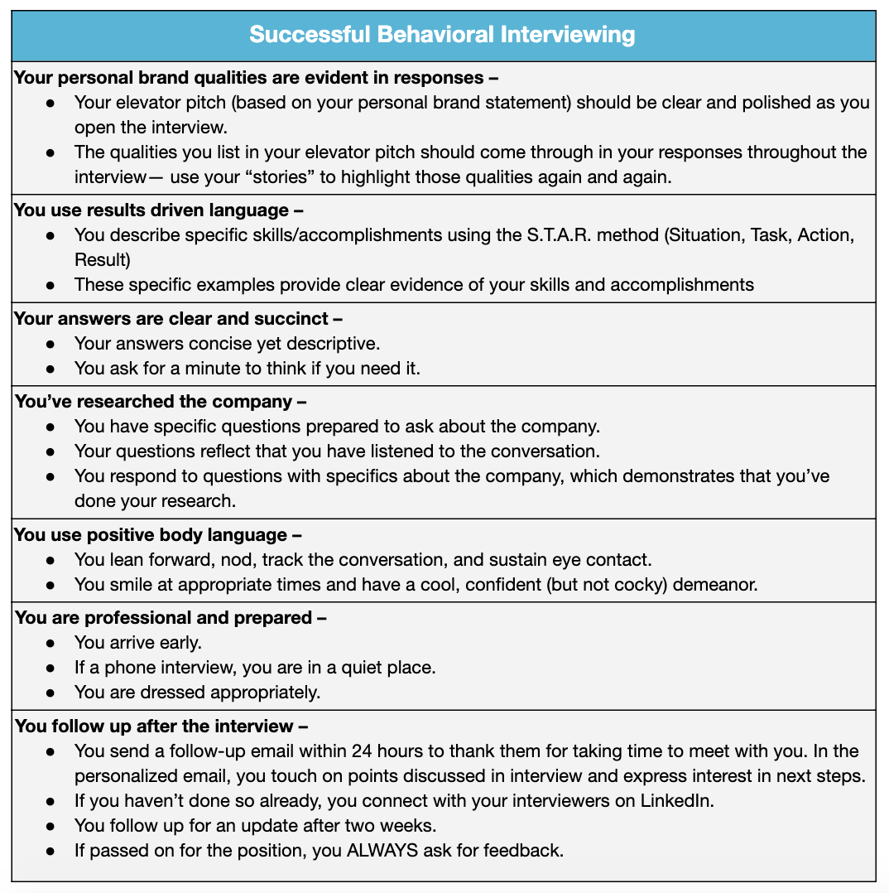

**TECHNICAL INTERVIEWING**

If you’re moving on to next steps in the interview process, you’re probably wondering how to prepare. Here, we’ll cover types of technical interviews so you can understand how to better prepare.

**Before we get started:**

* Figure out your strengths and gaps. If there are any coding languages that you feel you can improve on, start working on them now. Consider registering for each one of these websites below. They will help you prepare for the technical interview!
  + ​[TopCoder](https://www.topcoder.com/challenges/)​
  + ​[Machine Learning](https://github.com/zipfian/data-science-primer/tree/master/resources/coursera_ml)​
  + ​[Statistics + R](http://www.dataschool.io/15-hours-of-expert-machine-learning-videos/)​
  + ​[SQL](https://community.modeanalytics.com/sql/tutorial/introduction-to-sql/)​

**Technical Interviewer:**

The Technical Interviewer is usually someone with a technical background. They assess your technical skill set and may also ask you behavioral interview questions just to get to know you a little bit better. The technical interviewer usually assesses your skill set in one of the following ways:

* **Whiteboarding Sessions:**

Whiteboarding sessions are 30 minutes to full day interviews designed to test your critical thinking and problem-solving skills. You will be given a question that has to do with coding and be asked to answer this question using a whiteboard.

* **Pair Programming Sessions:**

Pair programming sessions are interviews that last 30 minutes to full day and are designed to test how you solve problems under pressure. You will be tasked with a coding challenge where you will have to program alongside members of the technical team.

* **Take Home Applications:**

Take home applications are challenges that the technical interviewer will send you before the first or second interview. You will have to complete a program or coding challenge and then discuss your thought process with the technical interviewer.

**ADDITIONAL RESOURCES**

* ​[How to Answer: Behavioral Interview Questions](https://www.youtube.com/watch?v=mH3DaeJSwy4)​
* ​[Using the STAR Method in Behavioral Interviews](https://www.youtube.com/watch?v=qKBubKO-798)​
* ​[What You Need to Know to Ace Your Technical Interview](https://www.glassdoor.com/blog/technical-interview-tips/)